SCORING TOOLS
Why Scoring tools???

Scoring tools are utilized in dermatology to score the severity of the disease state.
Not having adequate Scoring Tools in a visit note may lead to a denial in the Prior Auth process.

Reference below for scoring tools that are used as global assessments of Psoriasis, Atopic Dermatitis, Alopecia, Prurigo Nodularis and Vitiligo

IGA (Investigators Global Assessment)-Atopic Dermatitis
Usually used by investigators during clinical trials but mandated by most insurance companies for PA decision making

IGA  (Investigators Global Assessment)  0-4 Score | 0 - Clear  no signs of Eczema, some post-inflammatory hyperpigmentation may be present | 1 – Almost Clear  no thickening, normal or pink coloration | 2 - Mild  mild thickening, pink to light red coloration | 3 - Moderate  moderate thickening, dull to bright red | 4 - Severe  severe thickening, bright to deep red

PGA (Physicians Global Assessment) - Psoriasis
Used by clinicians in scoring disease severity and mandated by most insurance companies for PA decision making

PGA  (Physician’s Global Assessment)  0-4 Score | 0 - Clear  no signs of Psoriasis, some post-inflammatory hyperpigmentation may be present | 1 – Almost Clear  no thickening, normal or pink coloration | 2 - Mild  mild thickening, pink to light red coloration | 3 - Moderate  moderate thickening, dull to bright red | 4 - Severe  severe thickening, bright to deep red

BSA (Body Surface Area)- Atopic Dermatitis/ Psoriasis/ Vitiligo
This is in percentage range and 1% would be the size of the patients hand.

BSA  (Body Surface Area) | 0-3% - Mild | 3%-10% - Moderate | >10% - Severe

DLQI (Dermatology Quality of Life Index)- Alopecia/Atopic Dermatitis/ Psoriasis/Prurigo Nodularis/ Vitiligo
Set of ten questions asked to assess the impact on the patient’s quality of life from the condition that they have.
Scores range from 0-30-higher scores indicate a greater impact on the patient’s quality of life
DLQI (Dermatology Quality of Life Index) | 0-1  No Impact | 2-5  Little Impact | 6-10  Medium Impact | 11-20  High Impact | 21-30  Very High Impact
Questions for DLQI Scoring:
- Over the last week, how itchy, sore, painful, or stinging has your skin been?
  - Very much (3), A lot (2), A little (1), Not at all (0)
- Over the last week, how embarrassed or self conscious have you been because of your skin?
  - Very much (3), A lot (2), A little (1), Not at all (0)
- Over the last week, how much has your skin interfered with you going shopping or looking after your home or garden?
  - Very much (3), A lot (2), A little (1), Not at all (0), Not Relevant (0)
- Over the last week, how much has your skin influenced the clothes you wear?
  - Very much (3), A lot (2), A little (1), Not at all (0)
- Over the last week, how much has your skin affected any social or leisure activities?
  - Very much (3), A lot (2), A little (1), Not at all (0), Not Relevant (0)
- Over the last week, how much has your skin made it difficult for you to do any sport?
  - Very much (3), A lot (2), A little (1), Not at all (0), Not Relevant (0)
- Over the last week, has your skin prevented you from working or studying?
  - Yes (3), No (0), Not Relevant (0)
- If "No", over the last week how much has your skin been a problem at work or studying?
  - A lot (2), A little (1), Not at all (0)
- Over the last week, how much has your skin created problems with your partner or any of your close friends or relatives?
  - Very much (3), A lot (2), A little (1), Not at all (0), Not Relevant (0)
- Over the last week, how much has your skin caused any sexual difficulties?
  - Very much (3), A lot (2), A little (1), Not at all (0), Not Relevant (0)

SALT (Severity of Alopecia Tool)- Alopecia
Determine severity of hair loss.
Normal derived from assessing the 4 areas of the scalp: Top (40% SSA), Left (18% SSA), Right (18% SSA) and the Back (24% SSA) then determining how much loss is in each quadrant and adding the scores together

SALT (Severity of Alopecia Tool) | S0  No hair loss | S1  < 25% hair loss | S2  25-49% hair loss | S3  50-74% hair loss | S4  75-99% hair loss | S5  100%  Hair loss
Example of Scoring to get S0-S5 Above:

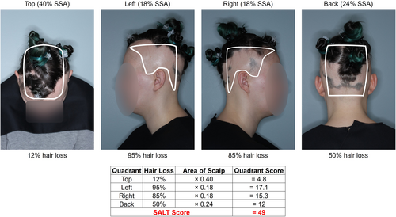**Image acquired from https://onlinelibrary.wiley.com/doi/full/10.1002/jvc2.327

EASI (Eczema Area and Severity Index)-Atopic Dermatitis
Grades the physical signs of atopic dermatitis/eczema using a Phyisician questionnaire that takes approximately 6-10 minutes to complete
EASI  (Eczema Area and Severity Index)-Atopic Dermatitis | 0  Clear | 0-1.0  Almost Clear | 1.1 - 7.0  Mild | 7.1 – 21.0  Moderate | 21.1 – 50.0  Severe | 50.1 – 72  Very Severe
Below is a sample graph of how to get an EASI Score for Adults and Pediatric Patients from Clear-Very Severe

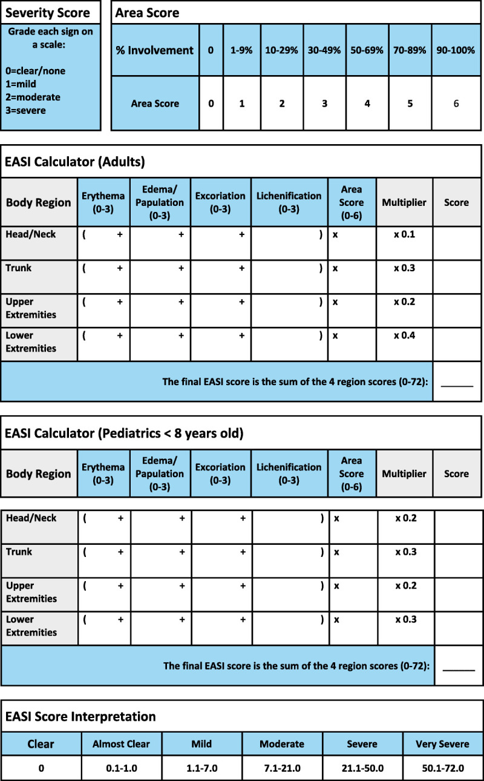***Image from https://www.ncbi.nlm.nih.gov/pmc/articles/PMC9154300/

VASI (Vitiligo Area Scoring Index)-Vitilgo
Scoring percentage of body surface area (BSA) using 1 hand (with palm) as 1%.
VASI (Vitiligo Area Scoring Index)-Vitilgo | 0%  Clear | 10%  only specks of depigmentation are present | 25%  the pigmented area exceeds the depigmented area | 50%  the depigmented and pigmented areas are equal | 75%  the depigmented area exceeds the pigmented area | 90%  specks of pigment are present | 100%  no pigment is present

POEM (Patient-Oreiented Eczema Measure)-Atopic Dermatitis
Core outcome instrument recommended for measuring patient reported AD symptoms using patient questionnaire
POEM (Patient-Oreiented Eczema Measure) | 0-2  Clear or Almost Clear | 3-7  Mild | 8-16  Moderate | 17-24  Severe | 25-28  Very Severe

POEM Questionnaire for All Patient Ages: (Points correspond next to answer)
- Over the last week, on how many days has your/your child’s skin been itchy because of the eczema?
  - No days(0) 1-2 days (1) 3-4 days(2) 5-6 days(3) Every day (4)
- Over the last week, on how many nights has your/your child’s sleep been disturbed because of the eczema?
  - No days(0) 1-2 days (1) 3-4 days(2) 5-6 days(3) Every day (4)
- Over the last week, on how many days has your/your child’s skin been bleeding because of the eczema?
  - No days(0) 1-2 days (1) 3-4 days(2) 5-6 days(3) Every day (4)
- Over the last week, on how many days has your/your child’s skin been weeping or oozing clear fluid because of the eczema?
  - No days(0) 1-2 days (1) 3-4 days(2) 5-6 days(3) Every day (4)
- Over the last week, on how many days has your/your child’s skin been cracked because of the eczema?
  - No days(0) 1-2 days (1) 3-4 days(2) 5-6 days(3) Every day (4)
- Over the last week, on how many days has your /your child’s skin been flaking off because of the eczema?
  - No days(0) 1-2 days (1) 3-4 days(2) 5-6 days(3) Every day (4)
- Over the last week, on how many days has your/your child’s skin felt dry or rough because of the eczema?
  - No days(0) 1-2 days (1) 3-4 days(2) 5-6 days(3) Every day (4)
Total POEM Score (Maximum 28): _________________

SCORAD (SCORing Atopic Dermatitis)
Used to determine extent of sites affected by eczema.
Score can be 0 up to 103 points to get the severity.

SCORAD (SCORing Atopic Dermatitis) | <25  Mild | 25-50  Moderate | >50-103  Severe
Assesses the Area Size: Head & Neck (9%), Upper limbs (9% each limb), Lower limbs (18% each limb), Anterior trunk (18%), Back (18%), Genitals (1%)***Score is added to get total up to 100

Assesses the Intensity:
Scoring each area with a 0 thru 3 scoring (0 -none, 1-mild, 2-moderate, 3-severe) Redness, Swelling, Oozing/Crusting, Scratch Marks, Skin thickening (lichenification), Dryness (this is assessed in an area where there is NO inflammation)***Score is added up to max total of 18

Assesses Subjective Symptoms:
Scoring each with 0 thru 10 score (0 is no itch/sleeplessness and 10 is worst imaginable itch/sleeplessness) Sleepiness and Itch***Score is added up to Max total of 20

*** The SCORAD formula is: a/5 + 7B/2+C.
Please keep in mind there are SEVERAL online SCORAD Calculators that will do the math and get the score for you.

PGSS (Pruritus Grading System Score)– Prurigo Nodularis
System utilized in Prurigo Nodularis studies to grade severity of disease Scoring 0-19
PGSS  (Pruritus Grading System Score) | 0-5  Mild | 6-11  Moderate | 12-19  Severe

Assessed and grade by each of the following Categories:
- Distribution
  - Solitary Site (1), Multiple Sites (2), Generalized (3)
- Frequency
  - Episodic (1), Frequent (3), Continuous (5)
- Severity
  - Rubbing (1), Scratching (1), Localized excoriations (3), Generalized excoriations (5)
- Sleep Disturbance
  - Rare (0), Occasional (2), Frequent (4), Totally restless (6)
Total Score Max is 19 to get Severity Above:

PAS (Pruigo Activity and Severity) – Prurigo Nodularis
Multi item scoring system to assess lesion type, number of lesions, affected body sites and scratch signs
PAS (Pruigo Activity and Severity) | Grade 0  0 lesions | Grade 1  1-19 lesions | Grade 2  20-100 lesions | Grade 3  >100 lesions

